Virpobe Paireepinart
CS 5338 / 3378 Formal Languages / Theory of Automata
Fall 2009
Assignment 6 (100 points, Chapters 17, 28)
Due: Dec 3, 09, Thursday, hard copy in class, *.jff files to TRACS
- (30) Design a TM to decide the language L = {0^{n}1^{n} | n ≥ 1}.
- Describe M in English.
1. Move right onto w. If the first character is black, halt and accept.

2. Loop:
2.1. Mark off a 0 with an ‘a’.
2.2. Move right to the first 1 and mark it off with a ‘b’a’s (the marked off 0’s). If there is another 0, go back to the top of the loop. If there isn’t, exit the loop.

3. All 0’s have found matching 1’s and the read/write head is just to the right of the region of marked off 0’s. Continue moving head to the right to verify that all 1’s have been marked. If they have, halt and accept. Otherwise halt and reject.

- Define M with transition diagram. (create a6-1b.jff and submit to TRACS, cut and paste figure below)
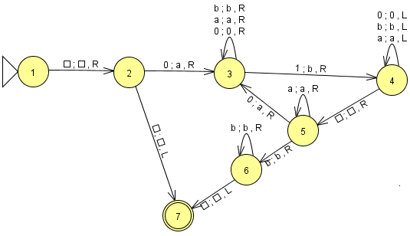

- Define M with transition table.

 | Symbol
State | empty | 0 | 1 | a | b
1 | (2, empty, R)
2 | (7, empty, R) | (3, a, R)
3 |  | (3, 0, R) | (4, b, R) | (3, a, R) | (3, b, R)
4 | (5, empty, R) | (4, 0 L) |  | (4, a, L) | (4, b, L)
5 |  | (3, a, R) |  | (5, a, R) | (6, b, R)
6 | (7, empty, L) |  |  |  | (6, b, R)

- (20) Design a TM to decide the language L = {0^{n} : n = 2^{k}, k ≥ 0}. Some example strings in L are 0, 00, 0000, 00000000 …

(a) Describe M in English.
1. Move right onto w. If the first character is black, halt and accept.
2. Mark off a 0 with an empty.
3. if there is another 0 mark it off with a ‘b’. If it’s empty, accept.
4. go back to the beginning.
4. Loop:
4.1. for every ‘b’, mark it as “empty”, then travel right and mark off the first two 0s you come to with ‘a’s.
4.2. go back to the begnning of the list. if there’s another ‘b’ go to the top of the loop. otherwise move on.
4.3. for every ‘a’, mark it as “empty”, then travel right and mark off the first two 0s you come to with ‘b’s.
4.4. go back to the beginning of the list. if there’s another ‘a’ then go to 4.3. otherwise go back to the top of the loop.

3. If there are any remaining 0’s, then reject. Otherwise accept.

(b) Define M with transition diagram. (create a6-2b.jff and submit to TRACS, cut and paste figure below)

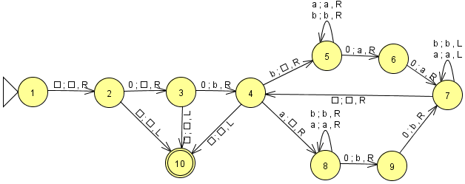

- (10) It is not known whether NP is closed under complement. But prove that it is closed under:

(a) Union.
If L1 and L2 are in NP, then there exist nondeterministic, polynomial-time Turing machines M1 and M2 that decide them. We show a new, nondeterministic, polynomial-time Turing machine M that decides L1 union L2. On input w, nondeterministically group every item in w into one of two distinct groups. Run M1 on the first group and M2 on the second. If both machines accept, accept.

(b) Concatenation.

If L1 and L2 are in NP, then there exist nondeterministic, polynomial-time Turing machines M1 and M2 that decide them. We show a new, nondeterministic, polynomial-time Turing machine M that decides L1L2. On input w, nondeterministically divide w into two pieces. Run M1 on the first piece and M2 on the second. If they both accept, accept.

(c) Kleene star.
Similarly to (b), except nondeterministically choose how many pieces to cut w into.

- 20) Show CLIQUE is NP-complete by first showing that it is in NP and then showing that it is NP-hard:

CLIQUE = {<G, k> : G is an undirected graph with vertices V and edges E, k is an integer, 1 ≤ k ≤ |V|, and G contains a k-clique}.

To show a CLIQUE is an NP problem we must examine an algorithm to find all of the cliques.
The simplest way to find all cliques is to take all subgraphs with k vertices and check to see if they form a clique. The number of subgraphs will be polynomial with respect to k in this case, so the running time of the algorithm in a nondeterministic sense will be polynomial (therefore this problem can be classified as NP.)

In order to show CLIQUE is NP-complete, we must exhibit an NDTM to decide it in polynomial time, or exhibit a DTM to verify it in polynomial time.
The above algorithm can be implemented in a NDTM to decide the CLIQUE in polynomial time. It will first subdivide the graph into all the possible subgraphs of ‘k’ size and then check all of the subgraphs for a k-clique. The time to analyze each graph will be polynomial. Therefore CLIQUE is NP-complete.

- (20) Theorem 28-20 (P661) shows that VERTEX-COVER is NP-complete by reduction from 3-SAT. In this question, show VERTEX-COVER is NP-complete by reduction from INDEPENDENT-SET.

Hint: The complement of an independent set is a vertex cover. i.e., Let N be the vertex set for graph G. If I is an independent set of G, then C = (N – I) is a vertex cover of G. If I is a maximal independent set for G, C is a minimal vertex cover for G.

We have proven that SAT is NP-Complete, and 3-SAT can be reduced from SAT, and INDEPENDENT SET can be reduced from 3-SAT. Therefore we know INDEPENDENT SET is NP-complete. In order to show that VERTEX-COVER is also NP-Complete we must reduce INDEPENDENT SET to VERTEX-COVER.

We already showed VERTEX-COVER is in NP. proving that VERTEX-COVER is NP-complete:
Proof: By reduction from INDEPENDENT SET:
Given a set of vertices N in graph G. There is a set I of vertices that are independent in G. Finding this set of vertices is NP-complete. Once you find this set of vertices, you can find the complement of the set in linear time. Therefore, because the original independent set takes polynomial time to discover, the linear time taken to complement the vertices is inconsequential (it is not the same factor of growth rate / complexity). Therefore, vertex-cover is also NP-complete.

- (10 bonus) Take a nap.

I did this. Was very relaxing.

